# JS Advanced: Exam 18.11.2018

# Problem 4. Real Estate Agency

Write a JavaScript program that **registers** and **finds** a real estate offers based on a given criteria.

Use the **index.html** and **app.js** **files** to solve this problem.

**Note:** You **can't** and you have **no permission** to change directly the given html code (index.html file).

### Output

You should **submit only** the **app.js file**

### Expected functionality:

### Reg offer field:

Rent price and commission rate should be **numbers**. Rent price must be **positive number** (greater than zero (0)). Commission rate should be greater or equal to zero (0) and lower or equal to one hundred (100). Apartment type should be **non-empty string** and **should not contain ':'** character.

If some of these conditions or all of them **are not met**, you should print the following message: '**Your offer registration went wrong, try again**.'

If **all is good** you should 'post' the new offer on the agency and print the following message: '**Your offer was created successfully**.'

After every click on the Reg Offer button (no matter of the result) the three fields (Rent price, Apartment type and Commission rate) must be **cleared**.

#### Reg offer Example:

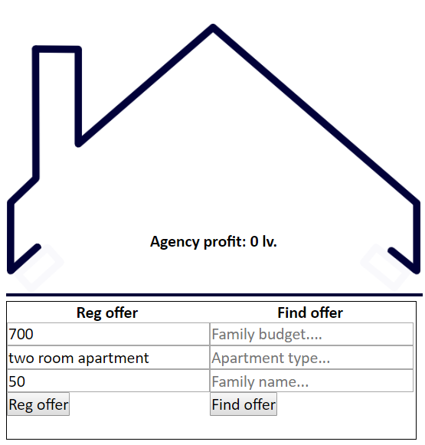

#### Reg offer Result:

When we click the Reg offer button, the result should be...

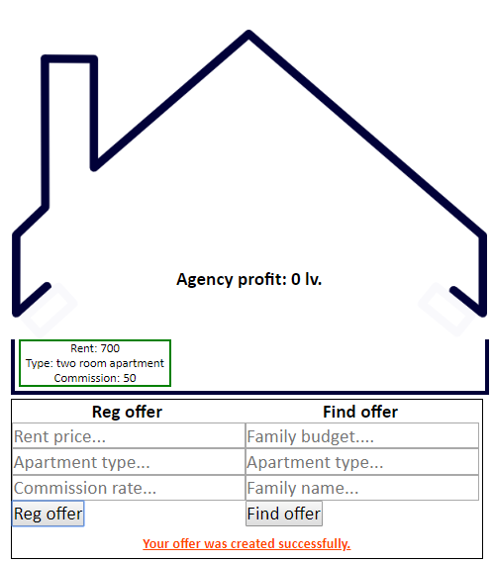

Successfully created, because every condition are met.

#### Reg offer Example 2

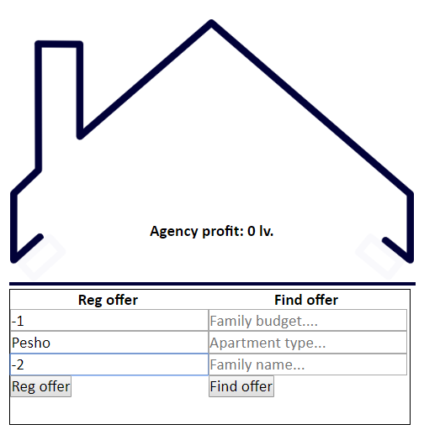

#### Example 2 Result:

When we click the Reg offer button, the result should be...

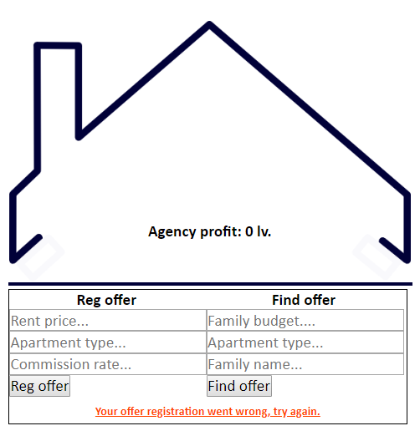

We do not create the new offer because one or all of the conditions are not met!

#### Code structure before create the new offer:

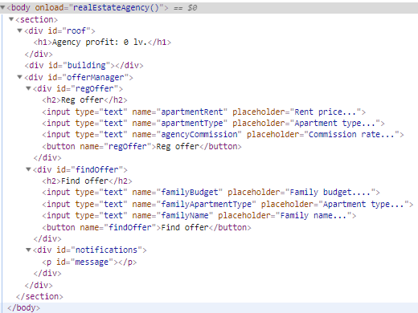

#### Code structure after we create the new offer:

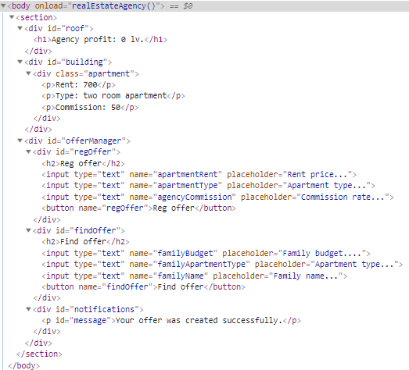

#### Code structure if reg offer went wrong:

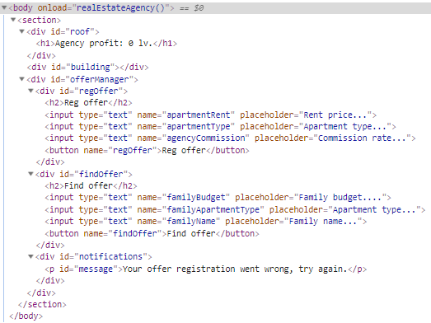

### Find offer field:

Family budget must be **positive number (greater than zero (0)).** Apartment type and Family name should be **non-empty strings**.

If **all is good** you should start searching through all registered offers into the agency. The first offer that meets the requirements, namely:

- The type of apartment you are looking for is **absolutely the same** as the registered one.

- The family budget needs to be **enough** to take the current apartment: rent + commission in percent of the current rental of the apartment.

**Is leased!** That means you should change the current apartment content and print the following message: **'Enjoy your new home! :))'.**

Also **on every successfully found offer**, the real estate agency, take the current commission from both sides.

**Example:**  
We find successfully two room apartment with 500 rent price and the commission for it is 50%. Current family needs to have at least 750 to take that offer (500 rent and 250 commission). If they do, the agency takes this 50% from the current family and 50% more from the other side (the owner of the apartment).

**Note:**  
The agency's profit is for all successfully found offers. The **h1** **element** into the **#roof** which contains the sentence **`Agency profit: {profit} lv.`** Shows the **total** profit for all offers.

If some of these conditions or all of them **are not met**, you should print the following message: '**We were unable to find you a home, so sorry :(**'

After every click on the Find Offer button (no matter of the result) the three fields (Family budget, Apartment type and Family name) must be **cleared**.

#### Find offer Example:

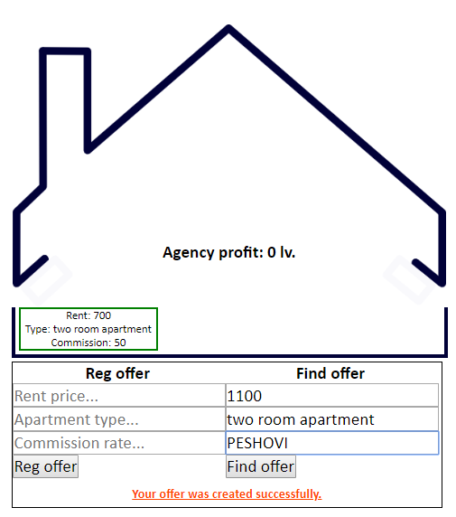

#### Find offer Example Result:

When we click the Find offer button, the result should be...

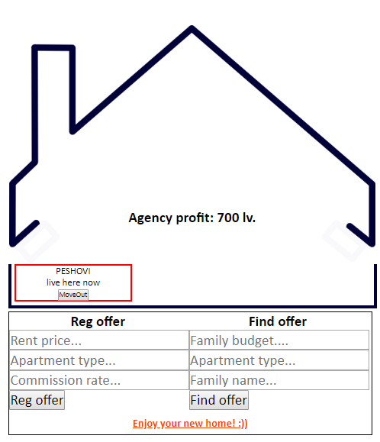

Successfully finded and rented out, because every condition are met.

#### Find Offer Example Result Code Structure:

### MoveOut Example:

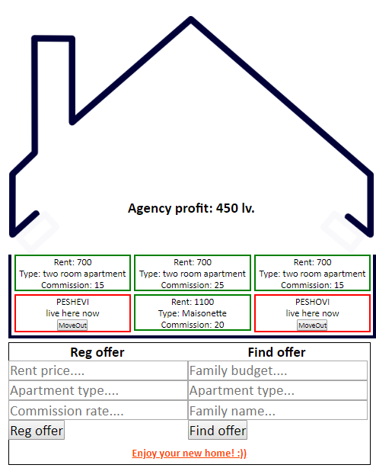

**MoveOut Result:**  
In this case if we click on the **PESHEVI's MoveOut button**, the whole apartment **must be removed**. And you should print the following message:   
**'They had found cockroaches in {familyName}\'s apartment'**

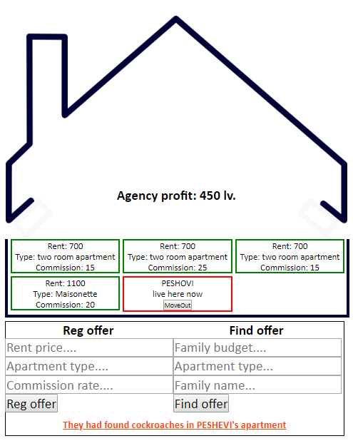

We removed successfully the whole PESHEVI's apartment because of the cockroaches..

#### MoveOut Example Result code structure:

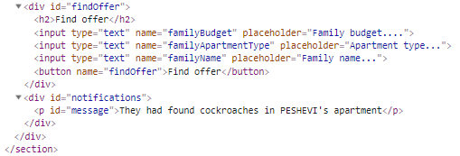

GOOD LUCK… C(: